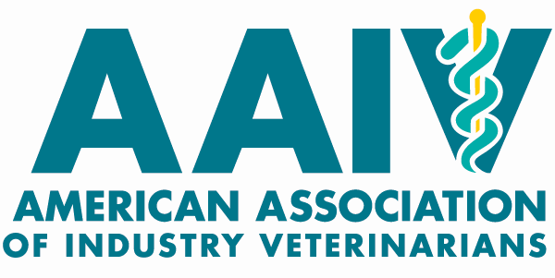
Board Member and Officer Nomination Form

Name of Nominee: AAIV Position:
Company:
Title:
Address: City: State: Zip:
Preferred Phone: Preferred Email:
Veterinary Medical Education (School and year of Graduation):

Other Degrees and Specialty Boards:

Why are you interested in Serving on the AAIV board or in the officer position?
May use a separate page, 150 word limit

What attributes would you bring to the AAIV board or to the officer position?
May use a separate page, 150 word limit

Candidate Agreement to Serve – I agree to serve on the AAIV Board of Directors in the position specified for which I am being nominated, and have read and understand the Board and Office Job Description presented to me. I understand and agree to the requirements that as a board member annually I will attend at least one in person board meeting (at VMX or AVMA) and at least 50% of the regularly scheduled phone/video conference calls. I certify that I am a current member of AVMA and AAIV, and the information provided above is true and accurate to the best of my knowledge.

Signature of Nominee Date

